The Jornada from Tucson to the Pima-Maricopa Villages
Pima-Maricopa Irrigation Project Education Initiative
2003-2004

Restoring water to ensure the
continuity of the Akimel O’otham
and Pee Posh tradition of agriculture

Re

Most emigrants were hardy people and, if they continued their journey past Santa Fe, New Mexico, were committed to completing their travels. Many viewed Santa Fe as the turning point, where the less hardy or discouraged gave up and returned to their homes back east or continued west over what proved to be the most difficult portion of the southern trails, with few provisions outside of a handful of small, scattered Mexican hamlets and the Pima and Maricopa villages. Before leaving Santa Fe, emigrants made final arrangements for their journey by pack mule down the Gila Trail or by wagon via the Southern Trail or one of its cutoffs.
Part 51

Emigrants on the southern trails took from three to six months or more to arrive at the gold fields in California. Other than an occasional scarcity of water, few travelers on the southern trails had trouble east of the Rio Grande, although some felt “grossly deceived as regards roads, time, distance, and in fact everything else.” For those on the Southern Trail, navigating the perpendicular walls of Guadalupe Pass was the first difficult obstacle outside of Santa Fe. While there were occasional Apache raids, supplies were generally available, especially for those following the Southern Trail through the Santa Cruz River Valley. The Gila Trail, while shorter, passed through desert riverine wilderness devoid of any villages save those of the Apache.
The most grueling part of the journey for emigrants on the Southern Trail was the jornada between Tucson and the Pima villages. It was here, for instance, where a group of Missouri emigrants “heard awful tales of the route ahead of us, dead animals strewing the road, wagons forsaken, human skeletons, who had famished for want of water.” Understanding these difficulties places into perspective the feelings of exhilaration and relief experienced by travelers upon reaching the Indian villages.
While not all travelers came via Tucson—some came down the Gila Trail—those that did, found water scarce and, when available, frequently contaminated with alkali. The ninety miles of dry, barren desert represented one of the most challenging tests emigrants experienced enroute to California. “Until one has crossed a barren desert without food or water under a burning tropical sun at a rate of three miles an hour,” an emigrant wrote about the jornada as he crossed it in late May of 1849, “he can form no conception of what misery is.”
The Santa Cruz River—along which the Southern Trail ran for much of its distance across Southern Arizona—flowed northwesterly until it sank beneath its sandy bed outside of Tucson, not reappearing until west of the Pima and Maricopa villages near Maricopa Wells. Men and animals frequently gave out enroute, with some emigrants sucking water from the mud of nearly dry desert ponds to stay alive. Forty-niner Harvey Wood found no water on the jornada and “suffered considerable from the want of it.” Some emigrants miscalculated the desert heat and the scarcity of water or found watering holes dried up upon their arrival. One emigrant carried just two quarts of water for the trip from Tucson to the Pima villages, nearly dying of thirst as a result. Clouds of fine, sterile dust from the desert floor compounded “a thirst most difficult to allay.”
Some travelers were left on the trail too exhausted and famished to continue. The Hampden Mining Company, of which Asa Clarke was a member, happened upon a Frenchman alongside the road from Tucson who was “delirious and nearly dead.” Emigrant John Durivage, having exhausted his supply of water, suffered from sunstroke. Believing the end was at hand—“swollen lips covered with froth, and the deathly paleness of my countenance”—Durivage resigned himself to a sure, torturous death. He survived only because a servant named Isaac rushed forward an estimated 15 miles to the Gila River and returned with water—“the nectar of the gods.” A member of the Black River Company traveling in the fall of 1849, noted a “humane Negro” retraced his steps for forty miles to bring water to a dying man he found along the trail. As he arrived, the emigrant “breathed his last.” His mule was tied to a cactus beside him, “dead of hunger.”
While blowing dust often obliterated the trail, conspicuous landmarks such as Picacho Peak and the Sacaton Mountains guided travelers. When there was water available, such as in the rocky crags of the Picacho Mountains, the large number of travelers quickly exhausted it. Benjamin Butler Harris estimated there were between 400 and 500 emigrants in Tucson waiting to travel to the villages when he entered the town in June 1849. Some of these emigrants purchased gourds of water—at “ten times their value”—in anticipation of the jornada. Most travelers carried as much water as possible, with those in wagons able to transport more. Robert Eccleston, traveling with the Fremont Association of New York, filled “3 casks & two Indian Rubber bags” with eighty gallons of water for the six day trip. John Audubon dug a well four feet deep in a desert wash and “found better water than we had had for some time.”
Despite desert storms during the summer, water—even when available—was not always drinkable. Crossing the Santa Cruz Flats northwest of Picacho Peak not only meant hardships caused by the alkali-laden dust but also represented potential death from alkali-contaminated water. With sodium bicarbonate common in arid lands, many of the limited water supplies were undrinkable. Robert Brownlee and the sixteen men in his Little Rock Company, for instance, departed Tucson early in the summer of 1849. Stopping at a watering hole enroute where they refreshed themselves, Brownlee “noticed a burning sensation, so I ate a piece of pork, which eased me right off.” Traveling companion Dr. William Fagan did not “and died the next morning” of alkali-contaminated water.
Within twenty-four hours a slave took sick and he, too, died. When an afternoon monsoon brought a flash flood, the wash in which the company was resting struggled to contain the two-foot high wall of water cascading down it. “You would think we had plenty of water to drink,” Brownlee continued, “but not so, as the ground was so charged with alkali that it was impossible to drink.” The party traveled two additional days without water before reaching the banks of the Gila River. Even those following the Gila Trail at times faced thirst and starvation. An emigrant traveling down the trail in July 1849 complained it was so hot and dry that “we wont have one oz of shortening in us by the time we get to San Francisco.”
The Jornada from Tucson to the Pima-Maricopa Villages

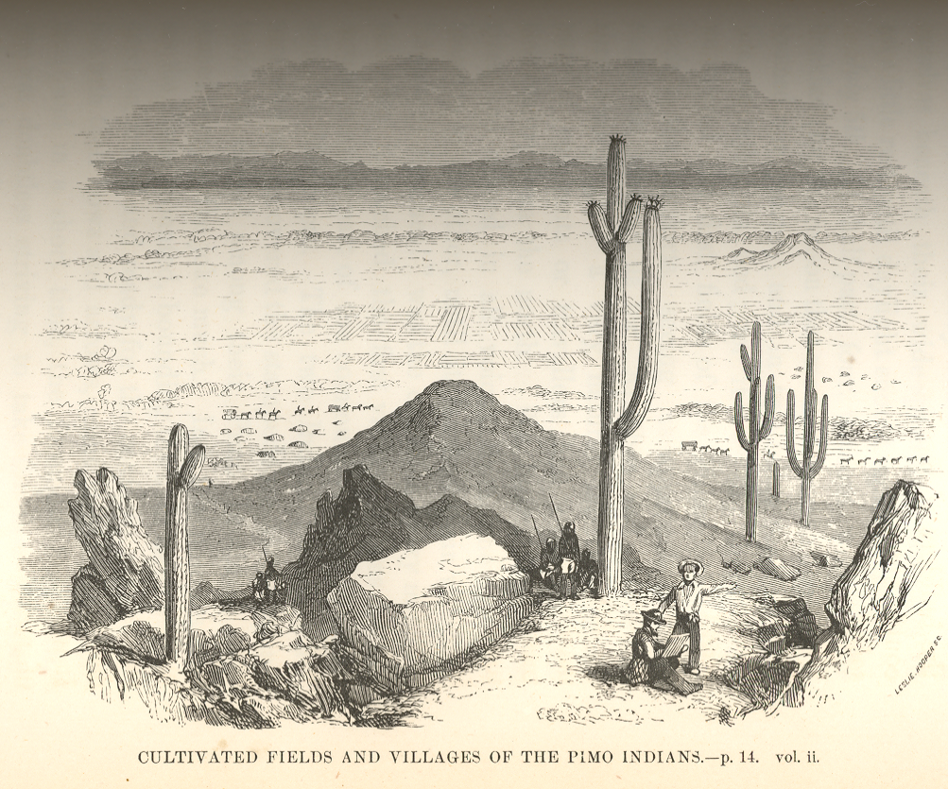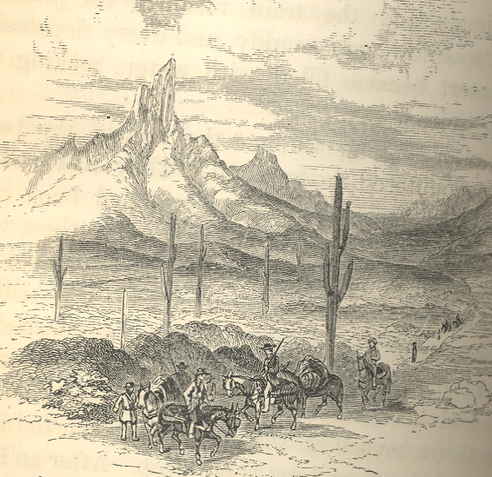
Teacher Plan for “The Jornada from Tucson to the Pima-Maricopa Villages”

Objectives

Students will be able to:

- Describe the general conditions under which emigrants traveled to the Pima villages.

- Analyze drawings and learn to cull information from them and draw conclusions.
Terms to know and understand

- Perpendicular
- Riverine
- Famished
- Exhilaration
- Conspicuous
Critical Thinking:

- Emigrants traveled an average of three miles per hour under good conditions. The ninety miles between Tucson and the Pima villages (the emigrant road struck the villages just east of modern Sacaton well above the Maricopa villages) could be made in a day and a half. Most travelers took from two to six days to travel it. If you were preparing to travel from Tucson to the villages in early June 1849 what supplies would you take with you? How much water would you have to carry along with you to sustain you—and your horses and mules? When would you travel? Explain your plans.
Activities:

- Reproduce the pictures on page 43 or show them to your students. Both pictures were drawn in 1852 and were included in John Russell Bartlett’s Personal Narrative of Explorations and Incidents in Texas, New Mexico, California, Sonora, and Chihuahua (New York: Appleton, 1854). This book chronicles the US-Mexican Boundary survey of 1852-1854.
- Ask students to carefully study the pictures. The top picture was probably drawn from the Sacaton Mountains looking to the north-northwest over the fields of Vak Ki (Casa Blanca). The lower picture was taken as the Southern Trail made its way through the pass at Picacho Peak.
- What geographic feature makes Picacho Peak unique? Do you think this made it easier or more difficult for travelers from Tucson to the Pima villages to find their way across the desert?
- Look carefully at the top picture. Beyond the mountains and the travelers, what does the picture tell you about the Pima and Maricopa? What else can you learn about the Pima and Maricopa by looking at this picture?
About P-MIP

The Pima-Maricopa Irrigation Project is authorized by the Gila River Indian Community to construct all irrigation systems for the Community. When fully completed, P-MIP will provide irrigation for up to 146,330 acres of farmland. P-MIP is dedicated to three long-range goals:
- Restoring water to the Akimel O’otham and Pee Posh.
- Putting Akimel O’otham and Pee Posh rights to the use of water to beneficial use.
- Demonstrating and exercising sound management to ensure continuity of the Community’s traditional economy of agriculture.

